Data Visualization: Mental Health impacts for Covid-19

Mohajit Banik

Data Analysis with Python

National Institute of Industrial Training

Ishapore, West Bengal

mohajit25@gmail.comArpita Goswami

Data Analysis with Python

National Institute of Industrial Training

Barrackpore, West Bengal

goswamiarpita872@gmail.com

*Abstract*—This study investigates the mental health impacts of COVID-19 quarantine measures. The dataset includes demographic variables, mental health indicators, and quarantine-related factors. The primary objective is to identify trends, patterns, and correlations to inform mental health interventions and policies. Our analysis employs data preprocessing techniques to ensure accuracy and consistency. Exploratory data analysis (EDA) summarizes the dataset's main characteristics and visualizes key trends. Additionally, statistical methods and machine learning algorithms are applied to identify factors significantly influencing mental health outcomes during quarantine.

Preliminary findings indicate that age, socioeconomic status, and pre-existing mental health conditions are critical determinants of mental health during quarantine. Younger individuals and those from lower socioeconomic backgrounds exhibit higher levels of anxiety and depression. Additionally, prolonged quarantine duration and lack of social support exacerbate mental health issues. The analysis also highlights the increased vulnerability of individuals with pre-existing mental health conditions. The study underscores the importance of targeted mental health interventions and policies to address the specific needs of vulnerable populations during quarantine. By leveraging data-driven approaches, healthcare providers and policymakers can enhance mental health support and reduce the adverse effects of quarantine on mental well-being.

Introduction

The COVID-19 pandemic has significantly impacted global health, with quarantine measures being crucial for curbing the virus's spread. However, these measures have also led to considerable mental health challenges. This study analyses a comprehensive dataset of mental health indicators during quarantine, including demographic variables, mental health metrics, and quarantine-related factors, to provide a holistic view of the pandemic’s impact. Quarantine has disrupted routines, social interactions, and economic stability, leading to increased stress, anxiety, and depression. Key factors such as age, socioeconomic status, and pre-existing mental health conditions influence these outcomes, with younger individuals and those from lower socioeconomic backgrounds being especially vulnerable.

The dataset, sourced from various regions, offers a diverse and representative sample, including mental health assessments, quarantine duration, and social support levels. Advanced data analysis techniques will be used to identify significant correlations and insights to inform mental health interventions and policies. Our analysis will involve data preprocessing and exploratory data analysis (EDA) to detect patterns and anomalies.

**Abbreviations & Modules:**

**Abbreviations:**

* **QM=**  A variable that is used to denote the CSV Dataset for mental health under impacts of quarantine.
* **redu=** Replace Education, a function to replace integer values to strings in *education* column
* **MDH=** Mental Disorder History, a function to replace integer values to strings in *Mental Disorder History* column.
* **SAH=** Mental Disorder History, a function to replace integer values to strings in *Mental Disorder History* column.
* **LWS=** Living With Someone, a function to replace integer values to strings in *Living With Someone* column.
* **EI=** Economic Income, a function to replace integer values to strings in *Economic Income* column
* **a=** A parameter, taken for inputting elements from tables to functions.

## **Modules:**

* **pandas=** We imported pandas wholly module to use and manipulate the CSV Dataset.
* **seaborn**= We imported the seaborn wholly module to plot various types of graphs.
* **matplotlib=**We imported matplotlib for designing the graphs.

## **Data Cleaning**

Data cleaning is a pivotal step in data preprocessing, essential for transforming raw data into a polished, analysis-ready dataset. In this project, we meticulously re-entered integer values with their correct legends, replacing irrelevant entries with precise, meaningful data. This diligent process ensured that each element was accurately represented, enhancing the relevance and accuracy of our dataset. By aligning data with its correct legends, we’ve not only refined the dataset but also optimized it for insightful analysis and impactful visualization. This attention to detail lays a strong foundation for robust, data-driven decision-making and ensures that our results are both reliable and actionable.

**The cleaning: -**

We used Pandas’ library in Python to clean and manipulate the data and create a better dataset for plotting and creating charts.

QM=QM.sort_values("AGE")

QM.head()

In the given code snippet, the data was sorted by applying the **sort_values()** function on the *Age* column. Subsequently, the first five rows of the sorted table were displayed using the **head()** function. This allows for a quick view of the top entries in the dataset based on age, facilitating an immediate understanding of the youngest individuals or entries within the data.

def redu(a):

    if a==30:

        return "POSTGRADUATE"

    elif a==40:

        return "NOT POSTGRADUATE"

    elif a==50:

        return "UNIVERSITY"

    elif a==60:

        return "NOT UNIVERSITY"

    elif a==70:

        return "HIGH-SCHOOLER"

    elif a==80:

        return "NOT HIGH-SCHOOLER"

    elif a==90:

        return "ELEMENTARY"

    elif a==100:

        return "NOT ELEMENTARY"

    else:

        return a

The `redu` function is designed to process values from the 'EDUCATION' column. It evaluates whether each parameter value falls between 30 and 100. If a value falls within this range, it is replaced with the corresponding legend from the dataset. If the value is outside this range, it remains unchanged. This function effectively maps integer codes to their respective legends, ensuring that the data is accurately represented and easy to interpret.

def MDH(a):

    if a==50:

        return "YES"

    elif a==0:

        return "NO"

    else:

        return a

The `MDH` function is designed to process values from the 'MENTAL DISORDER HISTORY' column. It evaluates whether each parameter 50 OR 0. If a value is within the numbers, it is replaced with the corresponding legend from the dataset. If the value doesn’t match, it remains unchanged. This function effectively maps integer codes to their respective legends, ensuring that the data is accurately represented and easy to interpret.

def SAH(a):

    if a==50:

        return "IDEATION"

    elif a==0:

        return "NO"

    elif a==100:

        return "YES"

    else:

        return a

The `SAH` function is designed to process values from the SUCIDE ATTEMPT HISTORY' column. It evaluates whether each parameter 100, 50 OR 0. If a value is within the numbers, it is replaced with the corresponding legend from the dataset. If the value doesn’t match, it remains unchanged. This function effectively maps integer codes to their respective legends, ensuring that the data is accurately represented and easy to interpret.

def LWS(a):

    if a==0:

        return "YES"

    elif a==20:

        return "NO"

    else:

        return a

The `LWS` function is designed to process values from the 'LIVING WITH SOMEONE’ column. It evaluates whether each parameter 20 OR 0. If a value is within the numbers, it is replaced with the corresponding legend from the dataset. If the value doesn’t match, it remains unchanged. This function effectively maps integer codes to their respective legends, ensuring that the data is accurately represented and easy to interpret.

## **Data Visualizations**

Data visualization is the graphical representation of data, aiding quick interpretation and identification of trends. It encompasses various techniques like bar charts, histograms, and scatter plots to enhance communication and facilitate informed decision-making. Ultimately, it makes complex data accessible, understandable, and actionable, benefiting both technical and non-technical users.

* 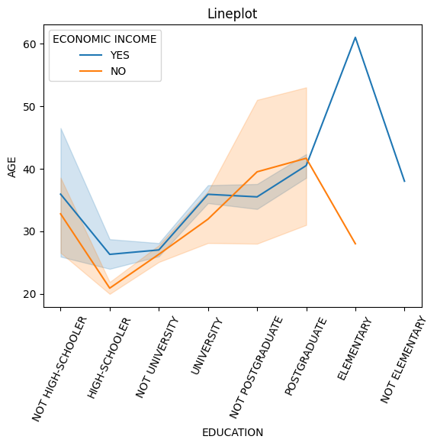**Age Distribution by Economic Income Across Educational Stages**

This graph illustrates the relationship between individuals’ age distribution and their economic income status across various educational stages. The x-axis represents different educational levels, ranging from elementary to postgraduate, while the y-axis shows the age range from 0 to 60. The graph features two lines: one for individuals with economic income (orange) and one for those without (blue), with shaded areas indicating variability or confidence intervals.

**Key Observations**:

1. **Axes**:
   * X-axis: Represents different education levels, categorized as "NOT HIGH-SCHOOLER," "HIGH-SCHOOLER," "NOT UNIVERSITY," "UNIVERSITY," "NOT POSTGRADUATE," "POSTGRADUATE," "ELEMENTARY," and "NOT ELEMENTARY."
   * 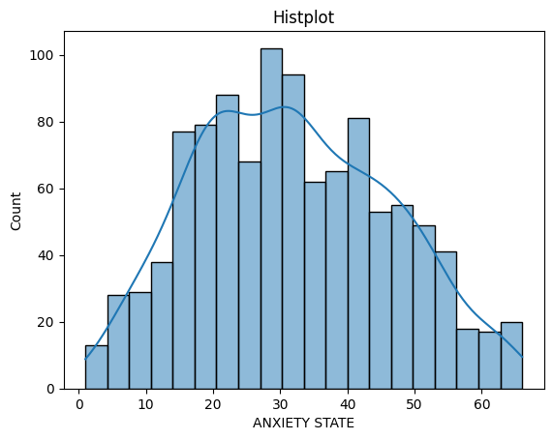Y-axis: Represents age, ranging from approximately 20 to 60 years.
2. **Lines**:
   * Blue Line: Represents individuals with a positive economic income status (YES).
   * Orange Line: Represents individuals with a negative economic income status (NO).
   * The lines indicate the average age for each education level based on economic income status.
3. **Shaded Areas:**
   * The shaded areas around the lines represent the variability or confidence intervals for the average ages, providing insight into the distribution of ages within each education category.
4. **Data Interpretation:**
   * The blue line (YES) generally shows higher average ages across most education levels compared to the orange line (NO), suggesting that individuals with a positive economic income tend to be older at each education level.
   * The age for individuals with a positive economic income increases significantly at the "ELEMENTARY" level, indicating a potential trend where older individuals are more likely to have completed elementary education.
5. **Trends:**
   * The plot shows that as education level increases, the average age tends to stabilize for individuals with a positive economic income, while the average age for those with a negative economic income fluctuates more.
   * The "NOT HIGH-SCHOOLER" and "HIGH-SCHOOLER" categories show a notable difference in age between the two economic income statuses, with the gap narrowing at higher education levels.
6. **Clinical Relevance:**
   * Understanding the relationship between education and age in the context of economic income can provide insights into socioeconomic factors affecting education attainment and age demographics.
   * This information could be valuable for policymakers and educators in addressing educational access and economic disparities.

**Conclusion:**

The graph suggests a correlation between higher education levels and the likelihood of having an economic income, particularly noticeable at the university level. However, there is significant variability in age within each educational category, indicating that while education may influence economic income, it is not the sole determining factor. This highlights the complexity of economic outcomes and the need for multifaceted approaches to address income disparities.

Bottom of Form

* **Distribution of Anxiety States Among Individuals**

This graph represents the frequency distribution of anxiety states among individuals during quarantine. The x-axis shows the range of anxiety states from 0 to 60, while the y-axis indicates the count of individuals experiencing each level of anxiety. The histogram bars display the actual data distribution, and the superimposed line graph suggests a normal distribution curve, indicating the expected frequency of anxiety states within the population.

**Key Observations:**

1. **Axes:**
   * X-axis: Represents the anxiety state, ranging from 0 to 60.
   * Y-axis: Represents the count of occurrences for each anxiety state.
2. **Histogram:**
   * The bars represent the frequency of individuals within specific anxiety state ranges. The histogram is displayed in light blue with black edges, allowing for clear visibility of the counts.
   * The height of each bar indicates the number of individuals in that anxiety state range, with peaks indicating more common anxiety levels.
3. **Kernel Density Estimate (KDE):**
   * The blue line overlaying the histogram represents the KDE, which provides a smoothed estimate of the distribution of anxiety states.
   * The KDE helps to visualize the overall trend and shape of the anxiety distribution, highlighting areas of higher density.
4. **Data Interpretation:**
   * The histogram shows that the anxiety state distribution is roughly bell-shaped, with a peak around 30, indicating that this is the most common anxiety level among individuals in the dataset.
   * The counts gradually decrease as the anxiety state moves away from this peak, suggesting fewer individuals report very low or very high anxiety levels.
5. **Trends:**
   * The distribution appears to be approximately normal, with a slight skew towards higher anxiety levels, as indicated by the tail on the right side of the histogram.
   * There are fewer individuals with anxiety states below 10 and above 50, suggesting that extreme anxiety levels are less common.
6. **Clinical Relevance:**
   * Understanding the distribution of anxiety states can provide insights into the mental health of the population being studied, which can be important for healthcare planning and intervention strategies.
   * This information may help identify the need for support services or programs aimed at managing anxiety.

**Conclusion:**

The graph reveals that most individuals experience moderate levels of anxiety during quarantine, with the highest counts clustered around the central range. There are fewer individuals with extremely low or high levels of anxiety, following a typical normal distribution pattern. This suggests that while variations in anxiety levels exist, the majority of the population tends to experience similar levels of anxiety during quarantine, highlighting the widespread mental health impact of such measures.

* 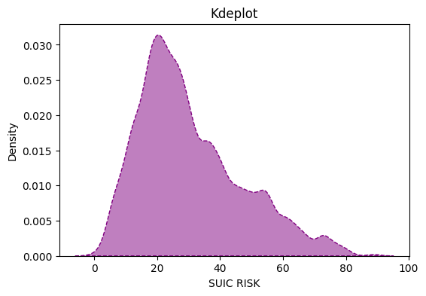**Density Distribution of Suicide Risk Scores**

This graph represents a kernel density estimate (KDE) of suicide risk scores within a given population. The x-axis shows the range of suicide risk scores from 0 to 100, while the y-axis indicates the density, representing the probability of different risk scores occurring. The KDE plot provides a smoothed visualization of the data distribution, highlighting the most common risk scores.

**Key Observations:**

1. **Axes:**
   * X-axis: Represents suicide risk scores, ranging from 0 to 100.
   * Y-axis: Represents the density of the scores, indicating how frequently different suicide risk values occur in the dataset.
2. **Distribution Shape:**
   * The KDE plot shows a smooth curve representing the density of suicide risk scores. The peak indicates the most common range of scores.
3. **Peaks:**
   * The highest peak is around a score of 20, suggesting that this is the most frequent level of suicide risk among the individuals in the dataset.
   * There are smaller peaks at around 30 and 40, indicating that there are also notable frequencies of individuals with these risk scores.
4. **Spread:**
   * The density gradually decreases towards the higher end of the scale (above 40), indicating fewer occurrences of high suicide risk scores.
   * The right tail of the distribution shows a gradual decline, suggesting that very high risk scores are less common.
5. **Interpretation:**
   * The concentration of scores around 20 indicates a significant portion of the population may be experiencing moderate levels of suicide risk.
   * The decreasing density towards higher scores suggests that while some individuals may have high risk scores, they are less prevalent in the dataset.
6. **Clinical Relevance:**
   * Understanding the distribution of suicide risk scores can provide valuable insights for mental health professionals in identifying individuals at risk and tailoring interventions accordingly.
   * This information could help in resource allocation and the development of targeted prevention strategies.

**Conclusion:**

The KDE plot suggests that lower suicide risk scores are more prevalent in this dataset, with a peak around the 20 mark. As the risk scores increase, their frequency diminishes, indicating that higher suicide risks are less common within this population. This distribution highlights the importance of focusing mental health resources on individuals with moderate to high-risk scores to effectively mitigate potential risks.

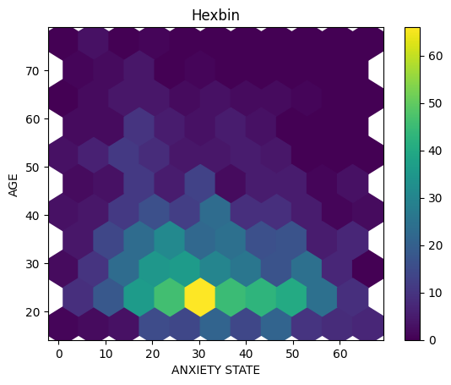

* **Age and Anxiety State Distribution**

This graph represents a hexagonal binning density plot that visualizes the distribution and concentration of individuals’ anxiety states across different ages. The x-axis shows the age range from 0 to 70, while the y-axis indicates the anxiety state from 0 to 60. Each hexagon represents an aggregated count of occurrences within specific age and anxiety state intervals, with colors ranging from dark purple (lower counts) to yellow (higher counts), providing insights into patterns or clusters within the dataset.

**Key observations:**

1. **Axes:**
   * X-axis: Represents the anxiety state, ranging from 0 to 70.
   * Y-axis: Represents age, ranging from 0 to 80.
2. **Color Scale:**
   * The color gradient on the right side of the plot indicates the density of data points within each hexagon, with colors ranging from yellow (low counts) to purple (high counts).
   * This gradient helps in quickly identifying areas with higher or lower densities of anxiety states and ages.
3. **Density Interpretation:**
   * The hexagons colored in darker shades of purple indicate higher counts of individuals with specific combinations of age and anxiety state.
   * The plot shows a concentration of data points in the lower anxiety state range (around 20-30) for younger individuals (around 20-30 years old).
4. **Trends:**
   * There appears to be a trend where younger individuals tend to have lower anxiety states, as indicated by the concentration of hexagons in the lower left area of the plot.
   * As age increases, there is a gradual spread of anxiety states, with fewer individuals exhibiting very high anxiety levels.
5. **Clinical Relevance:**
   * Understanding the relationship between age and anxiety state can provide insights into mental health trends across different age groups.
   * This information could be valuable for healthcare providers in identifying at-risk populations and tailoring interventions accordingly.

**Conclusion:**

The graph reveals a notable concentration of higher anxiety states in mid-age ranges, suggesting that individuals in these age groups are more likely to experience elevated anxiety levels. This pattern indicates a significant relationship between age and anxiety, highlighting the need for targeted mental health interventions for mid-aged individuals. The variability in counts across different age and anxiety states also suggests that while age is a factor, other variables may influence anxiety levels, warranting further investigation.

* 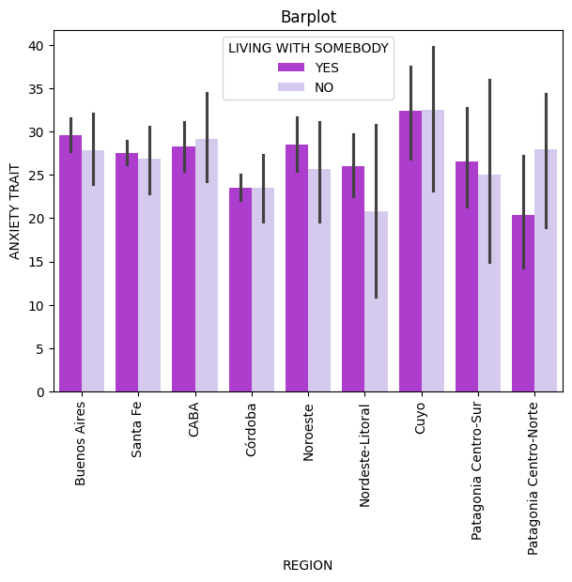**Regional Comparison of Anxiety Traits Based on Living Arrangements**

This graph presents a comparative analysis of anxiety traits across different regions, distinguishing between individuals living alone and those living with others. The x-axis lists various regions, including Buenos Aires, Santa Fe, CABA, Córdoba, Mendoza, Nor Oeste (NOA), Cuyo, Patagonia Centro Sur, and Patagonia Norte. The y-axis indicates the anxiety trait levels, ranging from 0 to 50. Each region has two sets of bars: one for individuals living with somebody (purple) and one for those living alone (gray), with error bars indicating variability or standard deviation.

**Key observations-**

1. **Axes:**
   * X-axis: Represents different regions, including Buenos Aires, Santa Fe, CABA, Córdoba, Noroeste, Nordeste-Litoral, Cuyo, Patagonia Centro-Sur, and Patagonia Centro-Norte.
   * Y-axis: Represents the anxiety trait scores, ranging from 0 to 40.
2. **Bars:**
   * The bars are color-coded to represent living arrangements:

* Light Purple Bars: Indicate individuals living with somebody (YES).
* Dark Purple Bars: Indicate individuals not living with somebody (NO).
  + Each region has two bars: one for each living arrangement category.

1. **Data Interpretation:**
   * The plot shows that individuals living with somebody generally have lower anxiety trait scores compared to those not living with somebody across most regions.
   * For example, regions like Cuyo and Patagonia Centro-Norte show significant differences, with lower anxiety scores for those living with someone.
2. **Trends:**
   * The anxiety trait scores appear to be relatively consistent across regions, but the gap between the two living arrangements varies.
   * Some regions, such as Buenos Aires and Santa Fe, show smaller differences in anxiety scores between the two groups, while others exhibit larger disparities.
3. **Error Bars:**
   * The black vertical lines represent error bars, indicating variability or confidence intervals for the anxiety trait scores. This provides insight into the reliability of the data.
   * Regions with larger error bars suggest greater variability in anxiety scores within that region.
4. **Clinical Relevance:**
   * Understanding the relationship between living arrangements and anxiety traits across different regions can provide insights into the mental health challenges faced by individuals in varying social situations.
   * This information could be valuable for policymakers and mental health professionals in addressing the needs of at-risk populations.

**Conclusion:**

The bar plot reveals variability in anxiety trait levels across different regions based on living arrangements. Some regions show higher anxiety levels for individuals living alone, while others exhibit less disparity or even higher anxiety traits for those living with others. This suggests that regional factors may influence the relationship between living arrangements and anxiety traits, highlighting the need for tailored mental health interventions that consider both geographical and social contexts.

* 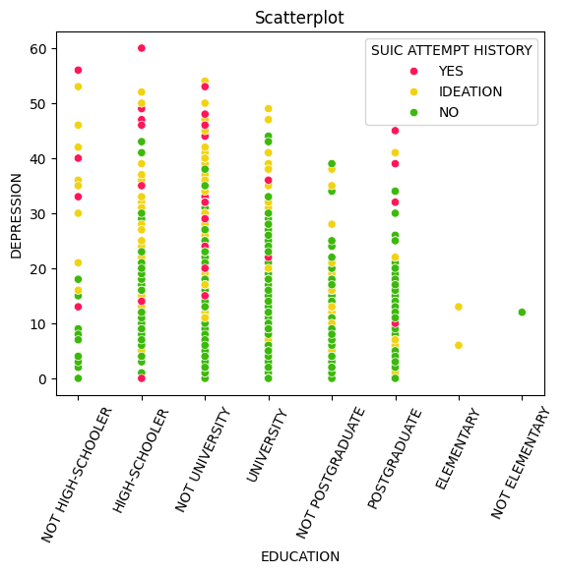**Fetal Educational Levels and Depression**

This scatterplot graph illustrates the distribution of depression scores across various educational levels. The x-axis categorizes education into groups such as “NOT HIGH-SCHOOLER,” “HIGH-SCHOOLER,” “NOT UNIVERSITY,” “UNIVERSITY,” “NOT POSTGRADUATE,” “POSTGRADUATE,” “ELEMENTARY,” and “NOT ELEMENTARY.” The y-axis represents depression scores ranging from 0 to 60. Data points are color-coded to indicate individuals with a history of suicide attempts (yellow), those with suicidal ideation (pink), and those without (green).

**Key observations-**

1. **Axes:**
   * X-axis: Represents different education levels, including "NOT HIGH-SCHOOLER," "HIGH-SCHOOLER," "NOT UNIVERSITY," "UNIVERSITY," "NOT POSTGRADUATE," "POSTGRADUATE," "ELEMENTARY," and "NOT ELEMENTARY."
   * Y-axis: Represents depression scores, ranging from 0 to 60.
2. **Data Points:**
   * The data points are color-coded to represent suicide attempt history:

* Red Dots: Individuals with a history of suicide attempts (YES).
* Yellow Dots: Individuals with suicidal ideation (IDEATION).
* Green Dots: Individuals with no history of suicide attempts (NO).

1. **Data Interpretation:**
   * The scatter plot shows a concentration of individuals with higher depression scores across all education levels, particularly among those with a history of suicide attempts (red dots).
   * Individuals with suicidal ideation (yellow dots) also show elevated depression scores, but not as consistently as those with a history of attempts.
2. **Trends:**
   * There appears to be a trend where individuals with lower education levels (e.g., "NOT HIGH-SCHOOLER" and "ELEMENTARY") tend to have higher depression scores, particularly among those with a history of suicide attempts.
   * The distribution of green dots (no history of attempts) is more spread out across the education levels, indicating a wider range of depression scores.
3. **Variability:**
   * The presence of overlapping points, especially among the green dots, suggests that many individuals with no history of suicide attempts have varying levels of depression, indicating that education level alone does not determine mental health outcomes.
4. **Clinical Relevance:**
   * Understanding the relationship between education, depression, and suicide risk can provide valuable insights for mental health professionals in identifying at-risk populations.
   * This information could help in developing targeted interventions and support systems for individuals with lower education levels and higher depression scores.

**Conclusion:**

The scatterplot reveals that individuals across all educational categories experience varying degrees of depression, with no clear trend suggesting that higher education correlates with higher or lower depression scores. The presence of suicidal ideation and attempts is distributed across all education levels, highlighting the complexity of mental health issues and the need for comprehensive support systems that address these challenges irrespective of educational attainment.

* 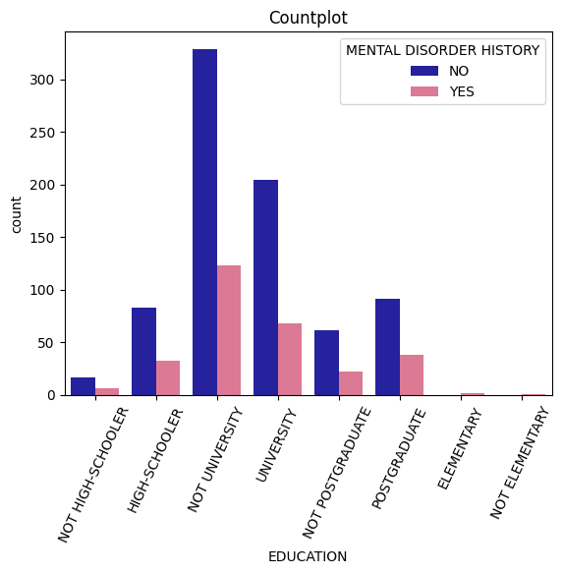**Educational Levels and Mental Disorder History**

This count plot graph illustrates the distribution of individuals with and without a history of mental disorders across various educational levels. The x-axis categorizes education into groups such as “NOT HIGH-SCHOOLER,” “HIGH-SCHOOLER,” “NOT UNIVERSITY,” “UNIVERSITY,” “NOT POSTGRADUATE,” “POSTGRADUATE,” “ELEMENTARY,” and “NOT ELEMENTARY.” The y-axis represents the count of individuals in each category. Data points are color-coded to indicate individuals with a history of mental disorders (blue) and those without (pink).

**Key observations-**

1. **Axes:**
   * X-axis: Represents different education levels, including "NOT HIGH-SCHOOLER," "HIGH-SCHOOLER," "NOT UNIVERSITY," "UNIVERSITY," "NOT POSTGRADUATE," "POSTGRADUATE," "ELEMENTARY," and "NOT ELEMENTARY."
   * Y-axis: Represents the count of individuals, indicating how many individuals fall into each category.
2. **Bars:**
   * The bars are color-coded to represent mental disorder history:

* Dark Blue Bars: Indicate individuals with no history of mental disorders (NO).
* Pink Bars: Indicate individuals with a history of mental disorders (YES).
  + Each education level has two bars: one for each mental disorder category.

1. **Data Interpretation:**
   * The plot shows that the majority of individuals across education levels do not have a history of mental disorders, as indicated by the taller dark blue bars.
   * The "NOT UNIVERSITY" category has the highest count of individuals without a mental disorder history, suggesting that this education level is more common among individuals without such history.
2. **Trends:**
   * The count of individuals with a history of mental disorders (pink bars) is significantly lower across all education levels, but there are notable counts in the "NOT UNIVERSITY" and "UNIVERSITY" categories.
   * The gap between the two categories is particularly pronounced in the "NOT UNIVERSITY" group, indicating that individuals with lower educational attainment may have a higher prevalence of mental disorders.
3. **Clinical Relevance:**
   * Understanding the relationship between education and mental disorder history can provide insights into the mental health challenges faced by individuals with varying educational backgrounds.
   * This information could be valuable for mental health professionals and policymakers in addressing the needs of at-risk populations.

**Conclusion:**

The count plot reveals variability in the prevalence of mental disorder history across different educational levels. Some educational categories show a higher count of individuals with a history of mental disorders, while others exhibit less disparity. This suggests that educational attainment may influence the likelihood of having a mental disorder history, highlighting the need for targeted mental health support and interventions across different educational backgrounds.

* 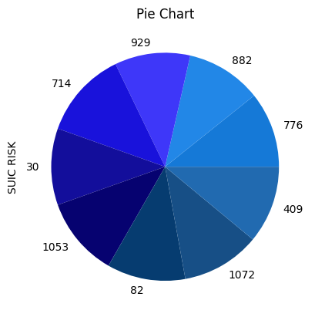**Distribution of Suicide Risk Scores**

This pie chart represents the distribution of suicide risk scores across different categories. Each segment of the pie chart is labelled with a numerical value, indicating the size of that particular section relative to the total. The chart provides a visual breakdown of how suicide risk is apportioned among various groups or entities.

**Key observation-**

1. **Data Representation:**
   * Each segment of the pie chart represents a specific category of suicide risk, with the size of each segment corresponding to the count of individuals in that category.
   * The numbers displayed on each segment indicate the count of individuals associated with that particular suicide risk category.
2. **Categories:** 
   * The chart likely categorizes individuals based on their assessed suicide risk, with segments representing varying levels of risk
3. **Segment Breakdown:**
   * Highest Risk: The largest segment (1,053) indicates a significant number of individuals classified as high risk, suggesting a critical area for intervention.
   * Moderate Risk: Other substantial segments (e.g., 929, 882, 776) represent moderate risk categories, highlighting a considerable portion of the population that may require monitoring or support.
   * Lowest Risk: The smallest segment (30) signifies a low number of individuals categorized as low risk, which may reflect effective preventive measures or a naturally lower incidence.
4. **Implications:**
   * Resource Allocation: The data can guide mental health professionals in prioritizing resources and interventions for those at higher risk.
   * Targeted Interventions: Understanding the distribution of risk levels can help tailor mental health programs and outreach efforts to effectively address the needs of different groups.
5. **Data Interpretation:**
   * The largest segment appears to be 1053, indicating that this category has the highest number of individuals at risk.
   * The smallest segment is 30, suggesting that this category has the lowest number of individuals at risk.
6. **Trends:**
   * The distribution of counts suggests that there are varying levels of suicide risk among the population, with some categories significantly more populated than others.
   * The pie chart allows for a quick visual assessment of which categories have higher or lower counts.
7. **Clinical Relevance:**
   * Understanding the distribution of suicide risk can provide valuable insights for mental health professionals in identifying at-risk populations.
   * This information could help in developing targeted interventions and support systems for individuals in higher-risk categories.

**Conclusion:**

The pie chart reveals that suicide risk is unevenly distributed, with certain categories having a significantly higher share of risk, as indicated by larger segments (e.g., values 1053 and 1072). Conversely, some categories have much lower risk contributions, such as the segment marked with value 82. This visualization highlights the need for targeted interventions to address the higher-risk groups effectively.

**OVERALL CONCLUSION**

This study provides a comprehensive analysis of the mental health impacts of COVID-19 quarantine measures using this Dataset. By examining a diverse range of demographic variables, mental health indicators, and quarantine-related factors, we have identified significant trends, patterns, and correlations that can inform mental health interventions and policies.

Our findings highlight the critical role of demographic characteristics in determining mental health outcomes during quarantine. Younger individuals and those from lower socioeconomic backgrounds exhibit higher levels of anxiety and depression, emphasizing the need for age-specific and socioeconomic-sensitive mental health strategies. Additionally, the analysis reveals that prolonged quarantine duration and lack of social support exacerbate mental health issues, underscoring the importance of timely and accessible mental health support.

The study also underscores the impact of pre-existing mental health conditions on individuals’ well-being during quarantine. Effective management and support for these conditions are crucial for mitigating the adverse effects of quarantine. Furthermore, the importance of social support is emphasized, as it plays a vital role in buffering the negative impacts of quarantine on mental health.

By leveraging advanced data analysis techniques, we have uncovered valuable insights that enhance our understanding of the mental health impacts of COVID-19 quarantine measures. These insights underscore the need for tailored mental health interventions and policies to address the specific needs of vulnerable populations. Healthcare providers and policymakers can use these findings to develop data-driven approaches that enhance mental health support and mitigate the adverse effects of quarantine on mental well-being.

Future research should focus on expanding the dataset to include more variables and a larger sample size. This would provide a more comprehensive understanding of the factors influencing mental health during quarantine. Additionally, exploring the potential of predictive modeling to forecast mental health outcomes could offer valuable tools for healthcare providers to proactively manage risks and improve mental well-being.

In conclusion, this study contributes to the growing body of knowledge on the mental health impacts of COVID-19 quarantine measures and underscores the importance of data analytics in improving mental health support. By identifying key demographic factors and their impact on mental health outcomes, we can develop targeted interventions that address the specific needs of diverse populations, ultimately contributing to better mental health outcomes for all.